National Institute of Technology Silchar

Cachar, Assam

B. Tech. IIIrd Semester

Branch- Computer Science and Technology

Assignment of Electronic Circuits and Switching

Subject Code- EC231

Submitted By:

Name : Subhojit Ghimire

Sch. Id. : 1912160

Branch : CSE ‘B’

Under the Guidance of:

Dr. S. K. Tripathi

Assistant Professor

Department of Electronics and Communication Engineering

NIT Silchar

**Q. 1. Simplify the following Boolean functions using three-variable maps.**

**a.** F (x, y, z) = Σ (0, 1, 5, 7)

Ans.

|  |  |  |  |  |
| --- | --- | --- | --- | --- |
| x, y →  z ↓ | 00 | 01 | 11 | 10 |
| 0 | 1 |  |  |  |
| 1 | 1 |  | 1 | 1 |

The simplified Boolean expression is, F = x’y’ + xz

**b.** F (x, y, z) = Σ (1, 2, 3, 6, 7)

Ans.

|  |  |  |  |  |
| --- | --- | --- | --- | --- |
| x, y →  z ↓ | 00 | 01 | 11 | 10 |
| 0 |  | 1 | 1 |  |
| 1 | 1 | 1 | 1 |  |

The simplified Boolean expression is, F = y + x’z

**c.** F (x, y, z) = Σ (3, 5, 6, 7)

Ans.

|  |  |  |  |  |
| --- | --- | --- | --- | --- |
| x, y →  z ↓ | 00 | 01 | 11 | 10 |
| 0 |  |  | 1 |  |
| 1 |  | 1 | 1 | 1 |

The simplified Boolean expression is, F = xy + yz + xz

**d.** F (A, B, C) = Σ (0, 2, 3, 4, 6)

Ans.

|  |  |  |  |  |
| --- | --- | --- | --- | --- |
| A, B →  C ↓ | 00 | 01 | 11 | 10 |
| 0 | 1 | 1 | 1 | 1 |
| 1 |  | 1 |  |  |

The simplified Boolean expression is, F = A’B + C’

**Q. 2. Simplify the following Boolean expressions using three-variable maps.**

**a.** xy + x’y’z’ + x’yz’

Ans.

|  |  |  |  |  |
| --- | --- | --- | --- | --- |
| x, y →  z ↓ | 00 | 01 | 11 | 10 |
| 0 | 1 | 1 | 1 |  |
| 1 |  |  | 1 |  |

The simplified Boolean expression is, F = x’z’ + xy

**b.** x’y’ + yz + x’yz’

Ans.

|  |  |  |  |  |
| --- | --- | --- | --- | --- |
| x, y →  z ↓ | 00 | 01 | 11 | 10 |
| 0 | 1 | 1 |  |  |
| 1 | 1 | 1 | 1 |  |

The simplified Boolean expression is, F = x’ + yz

**c.** A’B + BC’ + B’C’

Ans.

|  |  |  |  |  |
| --- | --- | --- | --- | --- |
| A, B →  C ↓ | 00 | 01 | 11 | 10 |
| 0 | 1 | 1 | 1 | 1 |
| 1 |  | 1 |  |  |

The simplified Boolean expression is, F = C’ + A’B

**Q. 3. Simplify the following Boolean functions using four-variable maps.**

**a.** F (A, B, C, D) = Σ (4, 6, 7, 15)

Ans.

|  |  |  |  |  |
| --- | --- | --- | --- | --- |
| A, B →  C. D ↓ | 00 | 01 | 11 | 10 |
| 00 |  | 1 |  |  |
| 01 |  |  |  |  |
| 11 |  | 1 | 1 |  |
| 10 |  | 1 |  |  |

The simplified Boolean expression is, F = A’BD’ + BCD

**b.** F (w, x, y, z) = Σ (2, 3, 12, 13, 14, 15)

Ans.

|  |  |  |  |  |
| --- | --- | --- | --- | --- |
| w, x →  y, z ↓ | 00 | 01 | 11 | 10 |
| 00 |  |  | 1 |  |
| 01 |  |  | 1 |  |
| 11 | 1 |  | 1 |  |
| 10 | 1 |  | 1 |  |

The simplified Boolean expression is, F = wx + w’x’y

**c.** F (A, B, C, D) = Σ (3, 7, 11, 13, 14, 15)

Ans.

|  |  |  |  |  |
| --- | --- | --- | --- | --- |
| A, B →  C. D ↓ | 00 | 01 | 11 | 10 |
| 00 |  |  |  |  |
| 01 |  |  | 1 |  |
| 11 | 1 | 1 | 1 | 1 |
| 10 |  |  | 1 |  |

The simplified Boolean expression is, F = CD + ABD + ABC

**Q. 4. Simplify the following Boolean functions using four-variable maps.**

**a.** F (w, x, y, z) = Σ (1, 4, 5, 6, 12, 14, 15)

Ans.

|  |  |  |  |  |
| --- | --- | --- | --- | --- |
| w, x →  y. z ↓ | 00 | 01 | 11 | 10 |
| 00 |  | 1 | 1 |  |
| 01 | 1 | 1 |  |  |
| 11 |  |  | 1 |  |
| 10 |  | 1 | 1 |  |

The simplified Boolean expression is, F = xz’ + wxy + w’y’z

**b.** F (A, B, C, D) = Σ (0, 1, 2, 4, 5, 7, 11, 15)

Ans.

|  |  |  |  |  |
| --- | --- | --- | --- | --- |
| A, B →  C. D ↓ | 00 | 01 | 11 | 10 |
| 00 | 1 | 1 |  |  |
| 01 | 1 | 1 |  |  |
| 11 |  | 1 | 1 | 1 |
| 10 | 1 |  |  |  |

The simplified Boolean expression is, F = A’C’ + ACD + BCD + A’B’D’

**c.** F (w, x, y, z) = Σ (2, 3, 10, 11, 12, 13, 14, 15)

Ans.

|  |  |  |  |  |
| --- | --- | --- | --- | --- |
| w, x →  y. z ↓ | 00 | 01 | 11 | 10 |
| 00 |  |  | 1 |  |
| 01 |  |  | 1 |  |
| 11 | 1 |  | 1 | 1 |
| 10 | 1 |  | 1 | 1 |

The simplified Boolean expression is, F = wx + x’y

**d.** F (A, B, C, D) = Σ (0, 2, 4, 5, 6, 7, 8, 10. 13. 15)

Ans.

|  |  |  |  |  |
| --- | --- | --- | --- | --- |
| A, B →  C. D ↓ | 00 | 01 | 11 | 10 |
| 00 | 1 | 1 |  | 1 |
| 01 |  | 1 | 1 |  |
| 11 |  | 1 | 1 |  |
| 10 | 1 | 1 |  | 1 |

The simplified Boolean expression is, F = A’B + BD + B’D’

**Q. 5. Simplify the following Boolean expressions using four-variable map.**

**a.** w’z + xz + x’y + wx’z

Ans.

|  |  |  |  |  |
| --- | --- | --- | --- | --- |
| w, x →  y, z ↓ | 00 | 01 | 11 | 10 |
| 00 |  |  |  |  |
| 01 | 1 | 1 | 1 | 1 |
| 11 | 1 | 1 | 1 | 1 |
| 10 | 1 |  |  | 1 |

The simplified Boolean expression is, F = z + x’y

**b.** B’D + A’BC’ + AB’C + ABC’

Ans.

|  |  |  |  |  |
| --- | --- | --- | --- | --- |
| A, B →  C, D ↓ | 00 | 01 | 11 | 10 |
| 00 |  | 1 | 1 |  |
| 01 | 1 | 1 | 1 | 1 |
| 11 | 1 |  |  | 1 |
| 10 |  |  |  | 1 |

The simplified Boolean expression is, F = BC’ + B’D + AB’C

**c.** AB’C + B’C’D’ + BCD + ACD’ +A’B’C + A’BC’D

Ans.

|  |  |  |  |  |
| --- | --- | --- | --- | --- |
| A, B →  C, D ↓ | 00 | 01 | 11 | 10 |
| 00 | 1 |  |  | 1 |
| 01 |  | 1 |  |  |
| 11 | 1 | 1 | 1 | 1 |
| 10 | 1 |  | 1 | 1 |

The simplified Boolean expression is, F = B’D’ + CD + AC + A’BD

**d.** wxy + yz + xy’z + x’y

Ans.

|  |  |  |  |  |
| --- | --- | --- | --- | --- |
| w, x →  y, z ↓ | 00 | 01 | 11 | 10 |
| 00 |  |  |  |  |
| 01 |  | 1 | 1 |  |
| 11 | 1 | 1 | 1 | 1 |
| 10 | 1 |  | 1 | 1 |

The simplified Boolean expression is, F = xz + wy + x’y

**Q. 6. Find the minterms of the following Boolean expressions by first plotting each function in a map.**

**a.** xy + yz + xy’z

Ans:

|  |  |  |  |  |
| --- | --- | --- | --- | --- |
| x, y →  z ↓ | 00 | 01 | 11 | 10 |
| 0 |  |  | 1  m6 |  |
| 1 |  | 1  m3 | 1  m7 | 1  m5 |

Therefore, F (x, y, z) = Σ (3, 5, 6, 7)

**b.** C’D + ABC’ + ABD’ + A’B’D

Ans:

|  |  |  |  |  |
| --- | --- | --- | --- | --- |
| A, B →  C, D ↓ | 00 | 01 | 11 | 10 |
| 00 |  |  | 1  m12 |  |
| 01 | 1  m1 | 1  m5 | 1  m13 | 1  m9 |
| 11 | 1  m3 |  |  |  |
| 10 |  |  | 1  m14 |  |

Therefore, F (A, B, C, D) = Σ (1, 3, 5, 9, 12, 13, 14)

**c.** wxy + x’z’ + w’xz

Ans:

|  |  |  |  |  |
| --- | --- | --- | --- | --- |
| w, x →  y, z ↓ | 00 | 01 | 11 | 10 |
| 00 | 1  m0 |  |  | 1  m8 |
| 01 |  | 1  m5 |  |  |
| 11 |  | 1  m7 | 1  m15 |  |
| 10 | 1  m2 |  | 1  m14 | 1  m10 |

Therefore, F (w, x, y, z) = Σ (0, 2, 5, 7, 8, 10, 14, 15)

**Q. 7. Simplify the following Boolean functions using by first finding the essential prime implicants.**

**a.** F (w, x, y, z) = Σ (0, 2, 4, 5, 6, 7, 8, 10, 13, 15)

Ans.

|  |  |  |  |  |
| --- | --- | --- | --- | --- |
| w, x →  y, z ↓ | 00 | 01 | 11 | 10 |
| 00 | 1  m0 | 1  m4 |  | 1  m8 |
| 01 |  | 1  m5 | 1  m13 |  |
| 11 |  | 1  m7 | 1  m15 |  |
| 10 | 1  m2 | 1  m6 |  | 1  m10 |

Here, the prime implicants are- xz, w’z’ and x’z’ (the obtained 3-quads).

The essential prime implicants are- xz, w’z’ and x’z’.

The simplified Boolean expression is, F (w, x, y, z) = xz + w’z’ + x’z’

**b.** F (A, B, C, D) = Σ (0, 2, 3, 5, 7, 8, 10, 11, 14, 15)

Ans.

|  |  |  |  |  |
| --- | --- | --- | --- | --- |
| A, B →  C, D ↓ | 00 | 01 | 11 | 10 |
| 00 | 1  m0 |  |  | 1  m8 |
| 01 |  | 1  m5 |  |  |
| 11 | 1  m3 | 1  m7 | 1  m15 | 1  m11 |
| 10 | 1  m2 |  | 1  m14 | 1  m10 |

The prime implicants are- A’BD, CD, AC and B’D’ (the obtained 1pair and 3 quads).

The essential prime implicants are- A’BD, CD, AC, B’D’.

The simplified Boolean expression is, F (A, B, C, D) = A’BD + CD + AC + B’D’

**c.** F (A, B, C, D) = Σ (1, 3, 4, 5, 10, 11, 12, 13, 14, 15)

Ans.

|  |  |  |  |  |
| --- | --- | --- | --- | --- |
| A, B →  C, D ↓ | 00 | 01 | 11 | 10 |
| 00 |  | 1  m4 | 1  m12 |  |
| 01 | 1  m1 | 1  m5 | 1  m13 |  |
| 11 | 1  m3 |  | 1  m15 | 1  m11 |
| 10 |  |  | 1  m14 | 1  m10 |

The prime implicants are- A’B’D, BC’ and AC (obtained 1 pair and 2 quads).

The essential prime implicants are- A’B’D, BC’ and AC.

The simplified Boolean expression is, F (A, B, C, D) = A’B’D + BC’ + AC

**Q. 8. Simplify the following Boolean functions using five variable maps.**

**a.** F (A, B, C, D, E) = Σ (0, 1, 4, 5, 16, 17, 21, 25, 29)

Ans.

|  |  |  |  |  |
| --- | --- | --- | --- | --- |
| B, C →  D, E ↓ | 00 | 01 | 11 | 10 |
| 00 | 1  m0 | 1  m4 |  |  |
| 01 | 1  m1 | 1  m5 |  |  |
| 11 |  |  |  |  |
| 10 |  |  |  |  |

For A = 0

|  |  |  |  |  |
| --- | --- | --- | --- | --- |
| B, C →  D, E ↓ | 00 | 01 | 11 | 10 |
| 00 | 1  m16 |  |  |  |
| 01 | 1  m17 | 1  m21 | 1  m29 | 1  m25 |
| 11 |  |  |  |  |
| 10 |  |  |  |  |

For A = 1

The simplified Boolean expression is, F (A, B, C, D, E) = A’B’D’ + AD’E + B’C’D’

**b.** F ( A, B, C, D, E) = Σ (0, 2, 3, 4, 5, 6, 7, 11, 15, 16, 18, 19, 23, 27, 31)

Ans.

|  |  |  |  |  |
| --- | --- | --- | --- | --- |
| B, C →  D, E ↓ | 00 | 01 | 11 | 10 |
| 00 | 1  m0 | 1  m4 |  |  |
| 01 |  | 1  m5 |  |  |
| 11 | 1  m3 | 1  m7 | 1  m15 | 1  m11 |
| 10 | 1  m2 | 1  m6 |  |  |

For A = 0

|  |  |  |  |  |
| --- | --- | --- | --- | --- |
| B, C →  D, E ↓ | 00 | 01 | 11 | 10 |
| 00 | 1  m0 |  |  |  |
| 01 |  |  |  |  |
| 11 | 1  m3 | 1  m7 | 1  m15 | 1  m11 |
| 10 | 1  m2 |  |  |  |

For A = 1

The simplified Boolean expression is, F (A, B, C, D, E) = A’B’C + B’C’E + DE

**c.** F = A’B’CE’ + A’B’C’D’ + B’D’E’ + B’CD’ + CDE’ + BDE’

Ans.

|  |  |  |  |  |
| --- | --- | --- | --- | --- |
| B, C →  D, E ↓ | 00 | 01 | 11 | 10 |
| 00 | 1  m0 | 1  m4 |  |  |
| 01 | 1  m1 | 1  m5 |  |  |
| 11 |  |  |  |  |
| 10 |  | 1  m6 | 1  m14 | 1  m10 |

For A = 0

|  |  |  |  |  |
| --- | --- | --- | --- | --- |
| B, C →  D, E ↓ | 00 | 01 | 11 | 10 |
| 00 | 1  m0 | 1  m4 |  |  |
| 01 |  | 1  m5 |  |  |
| 11 |  |  |  |  |
| 10 |  |  | 1  m14 | 1  m10 |

For A = 1

The simplified Boolean expression is,

F (A, B, C, D, E) = A’B’D’ + B’D’E’ + B’CD’ + CDE’ + BDE’

**Q. 9. Simplify the following Boolean functions in product of sums.**

**a.** F (w, x, y, z) = Σ (0, 2, 5, 6, 7, 8, 10)

Ans.

This Boolean function can be written as,

F (w, x, y, z) = π (1, 3, 4, 9, 11, 12, 13, 14, 15)

|  |  |  |  |  |
| --- | --- | --- | --- | --- |
| w, x →  y, z ↓ | 0 + 0 | 0 + 1 | 1 + 1 | 1 + 0 |
| 0 + 0 |  | 0  m4 | 0  m12 |  |
| 0 + 1 | 0  m1 |  | 0  m13 | 0  m9 |
| 1 + 1 | 0  m3 |  | 0  m15 | 0  m11 |
| 1 + 0 |  |  | 0  m14 |  |

The simplified Boolean expression is, F (w, x, y, z) = (x + z’) (w’ + x’) (x’ + y + z)

**b.** F (A, B, C, D) = π (1, 3, 5, 7, 13, 15)

Ans.

|  |  |  |  |  |
| --- | --- | --- | --- | --- |
| A, B →  C, D ↓ | 0 + 0 | 0 + 1 | 1 + 1 | 1 + 0 |
| 0 + 0 |  |  |  |  |
| 0 + 1 | 0  m1 | 0  m5 | 0  m13 |  |
| 1 + 1 | 0  m3 | 0  m7 | 0  m15 |  |
| 1 + 0 |  |  |  |  |

The simplified Boolean expression is, F (A, B, C, D) = (A + D’) (B’ + D’)

**c.** F (x, y, z) = Σ (2, 3, 6, 7)

Ans.

This Boolean function can be written as, F (x, y, z) = π (0, 1, 4, 5)

|  |  |  |  |  |
| --- | --- | --- | --- | --- |
| x, y →  z ↓ | 0 + 0 | 0 + 1 | 1 + 1 | 1 + 0 |
| 0 | 0  m0 |  |  | 0  m4 |
| 1 | 0  m1 |  |  | 0  m5 |

The simplified Boolean expression is, F (x, y, z) = y

**d.** F (A, B, C, D) = π (0, 1, 2, 3, 4, 10, 11)

Ans.

|  |  |  |  |  |
| --- | --- | --- | --- | --- |
| A, B →  C, D ↓ | 0 + 0 | 0 + 1 | 1 + 1 | 1 + 0 |
| 0 + 0 | 0  m0 | 0  m4 |  |  |
| 0 + 1 | 0  m1 |  |  |  |
| 1 + 1 | 0  m3 |  |  | 0  m11 |
| 1 + 0 | 0  m2 |  |  | 0  m10 |

The simplified Boolean expression is, F (A, B, C, D) = (A + B) (B + C’) (A + C + D)

**Q. 10. Simplify the following expressions in (i) sum of products (ii) product of sums**

**a.** x’z’ + y’z’ + xy

Ans.

(i)

|  |  |  |  |  |
| --- | --- | --- | --- | --- |
| x, y →  z ↓ | 00 | 01 | 11 | 10 |
| 0 | 1  m0 | 1  m2 | 1  m6 | 1  m4 |
| 1 |  |  | 1  m7 |  |

The simplified Boolean expression in SOP is given as, F (x, y, z) = xy + z’

(ii)

|  |  |  |  |  |
| --- | --- | --- | --- | --- |
| x, y →  z ↓ | 00 | 01 | 11 | 10 |
| 0 |  |  |  |  |
| 1 | 0  m1 | 0  m3 |  | 0  m5 |

The compliment of the function is, F’ = x’z + y’z

Hence, the simplified Boolean expression for POS form is, F (x, y, z) = (x + z’) (y + z’)

**b.** AC’ + B’D + A’CD + ABCD

Ans.

(i)

|  |  |  |  |  |
| --- | --- | --- | --- | --- |
| A, B →  C, D ↓ | 00 | 01 | 11 | 10 |
| 00 |  |  | 1 | 1 |
| 01 | 1 |  | 1 | 1 |
| 11 | 1 | 1 | 1 | 1 |
| 10 |  |  |  |  |

The simplified Boolean expression for SOP form is, F = AC’ + B’D + CD

(ii)

|  |  |  |  |  |
| --- | --- | --- | --- | --- |
| w, x →  y, z ↓ | 00 | 01 | 11 | 10 |
| 00 | 0 | 0 |  |  |
| 01 |  | 0 |  |  |
| 11 |  |  |  |  |
| 10 | 0 | 0 | 0 | 0 |

The compliment of the function is, F’ = A’D’ + CD’ + A’BC’

The simplified Boolean expression for POS form is, F = (A + D) (C’ +D) (A + B’ + C)

**c.** (A’ + B’ + D’) (A + B’ C’) (A’ +B +D’)

Ans.

(i)

|  |  |  |  |  |
| --- | --- | --- | --- | --- |
| A, B →  C, D ↓ | 00 | 01 | 11 | 10 |
| 00 | 1 | 1 | 1 | 1 |
| 01 | 1 | 1 |  |  |
| 11 |  |  |  |  |
| 10 | 1 |  | 1 | 1 |

The simplified Boolean expression in SOP form is, F = A’C’ + AD’ + B’D’

(ii)

|  |  |  |  |  |
| --- | --- | --- | --- | --- |
| w, x →  y, z ↓ | 00 | 01 | 11 | 10 |
| 00 |  |  |  |  |
| 01 |  |  | 0 | 0 |
| 11 | 0 | 0 | 0 | 0 |
| 10 |  | 0 |  |  |

The compliment of the function is, F’ = AD + CD + A’BC

The simplified Boolean expression for POS form is, F = (A’ + D’) (C’ + D’) (A + B’ + C’)

**Q. 11. Draw the AND-OR gate implementation of the following function after simplifying in (a) sum of products (b) product of sums.**

**F (A, B, C, D) = Σ (0, 2, 5, 6, 7, 8, 10)**

Ans.

(a)

|  |  |  |  |  |
| --- | --- | --- | --- | --- |
| A, B →  C, D ↓ | 00 | 01 | 11 | 10 |
| 00 | 1 |  |  | 1 |
| 01 |  | 1 |  |  |
| 11 |  | 1 |  |  |
| 10 | 1 | 1 |  | 1 |

The simplified SOP form is, F = B’D’ + A’BD + A’BC

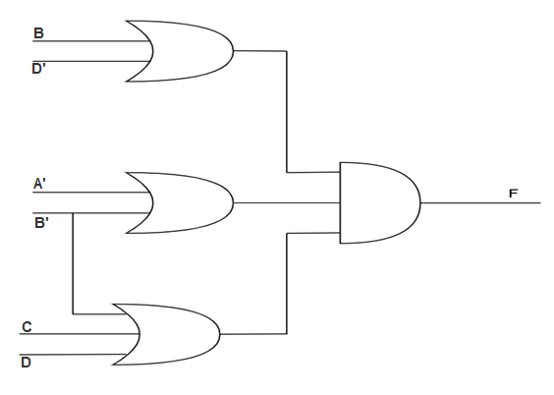

(b)

|  |  |  |  |  |
| --- | --- | --- | --- | --- |
| A, B →  C, D ↓ | 00 | 01 | 11 | 10 |
| 00 |  | 0 | 0 |  |
| 01 | 0 |  | 0 | 0 |
| 11 | 0 |  | 0 | 0 |
| 10 |  |  | 0 |  |

The compliment of the function, F’ = AB + B’D + BC’D’

Therefore, the simplified POS form is, F = (A’ + B’) (B + D’) (B’ + C + D)

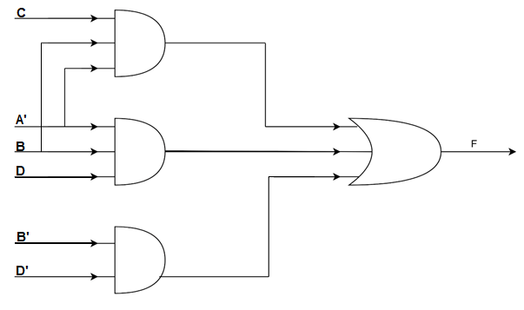

**Q. 12. Simplify the following expressions and implement them with two-level NAND gate circuits.**

**a.** AB’ + ABD + ABD’ + A’C’D’ + A’BC’

Ans.

|  |  |  |  |  |
| --- | --- | --- | --- | --- |
| A, B →  C, D ↓ | 00 | 01 | 11 | 10 |
| 00 | 1 | 1 | 1 | 1 |
| 01 |  | 1 | 1 | 1 |
| 11 |  |  | 1 | 1 |
| 10 |  |  | 1 | 1 |

The simplified Boolean expression is, F = A + C’D’ + BC’

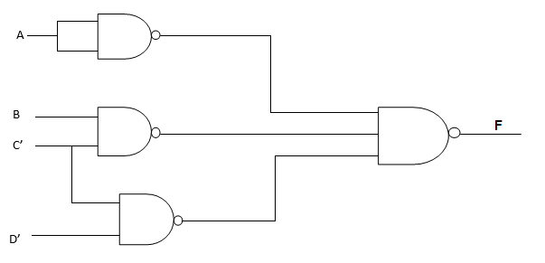

**b.** BD + BCD’ + AB’C’D’

Ans.

|  |  |  |  |  |
| --- | --- | --- | --- | --- |
| A, B →  C, D ↓ | 00 | 01 | 11 | 10 |
| 00 |  |  |  | 1 |
| 01 |  | 1 | 1 |  |
| 11 |  | 1 | 1 |  |
| 10 |  | 1 | 1 |  |

The simplified Boolean expression is, F = BD + BC + AB’C’D’

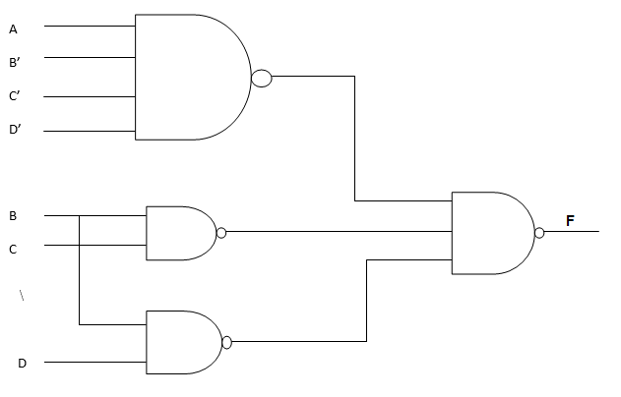

**Q. 13. Draw a NAND logic diagram that implement the complement of the following function.**

F (A, B, C, D) = Σ (0, 1, 2, 3, 4, 8, 9, 12)

Ans.

|  |  |  |  |  |
| --- | --- | --- | --- | --- |
| A, B →  C, D ↓ | 00 | 01 | 11 | 10 |
| 00 |  |  |  |  |
| 01 |  | 0 | 0 |  |
| 11 |  | 0 | 0 | 0 |
| 10 |  | 0 | 0 | 0 |

The compliment of the function is, F’ = BD + BC + AC

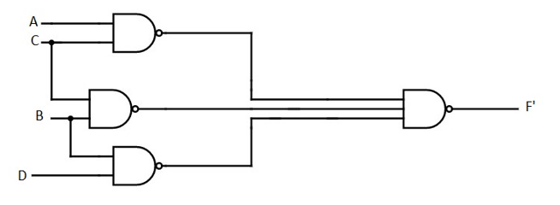

**Q. 14. Draw a logic diagram using only two-input NAND gates to implement the following expression.**

**(AB + A’B’) (CD’ + C’D)**

Ans.

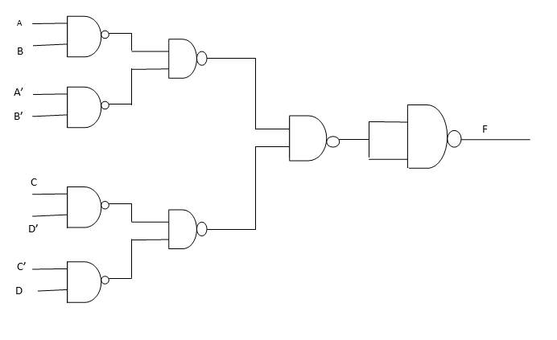

**Q. 15. Simplify the following functions and implement them with two-level NOR gate circuits.**

**a.** F = wx’ + y’z’ + w’yz’

Ans.

|  |  |  |  |  |
| --- | --- | --- | --- | --- |
| w, x →  y, z ↓ | 00 | 01 | 11 | 10 |
| 00 |  |  |  |  |
| 01 | 0 | 0 | 0 |  |
| 11 | 0 | 0 | 0 |  |
| 10 |  |  | 0 |  |

The compliment of the function is, F’ = w’z + xz + wxy

POS form, F = (w + z’) (x’ + z’) (w’ + x’ + y’)

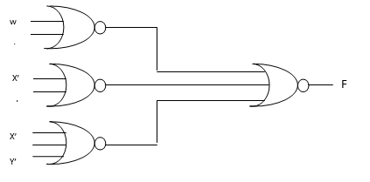

**b.** F (w, x, y, z) = Σ (5, 6, 9 ,10)

Ans.

|  |  |  |  |  |
| --- | --- | --- | --- | --- |
| w, x →  y, z ↓ | 00 | 01 | 11 | 10 |
| 00 | 0 | 0 | 0 | 0 |
| 01 | 0 |  | 0 |  |
| 11 | 0  v | 0 | 0  v | 0  v |
| 10 | 0 |  | 0 |  |

The compliment of the function is, F’ = w’x’ + wx + y’z’ + yz

POS form, F = (w + x) (w’ + x’) (y + z) (y’ + z’)

**Q. 16. Implement the functions of Q. 15 with three-level NOR gate circuits.**

Ans.

(a)

|  |  |  |  |  |
| --- | --- | --- | --- | --- |
| w, x →  y, z ↓ | 00 | 01  v | 11 | 10 |
| 00 | 1  v | 1 | 1 | 1 |
| 01 |  |  |  | 1 |
| 11 |  |  |  | 1 |
| 10 | 1 | 1 |  | 1  v  v |

SOP form, F = wx’ + y’z’ + w’yz’

F’ = (w’ + x) (y + z) (w + z)

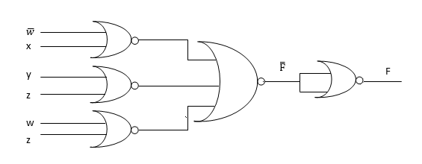

(b)

|  |  |  |  |  |
| --- | --- | --- | --- | --- |
| w, x →  y, z ↓ | 00 | 01 | 11 | 10 |
| 00 |  |  |  |  |
| 01 |  | 1  v |  | 1  v |
| 11 |  |  |  |  |
| 10 |  | 1  v |  | 1  v |

SOP form, F = w’xy’z + w’xyz’ + wx’y’z + wx’yz’

F’ = (w + x’ + y + z’) (w + x’ + y’ + z) (w’ + x + y + z’) (w’ + x + y’ +z)

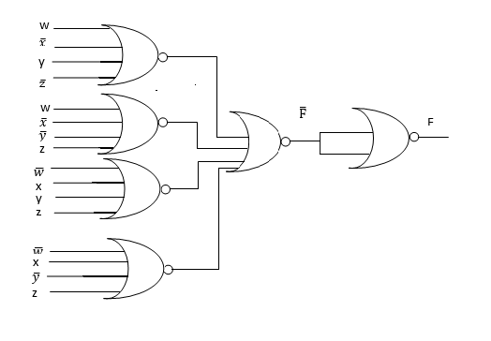

**Q. 17. Implement the expressions of Q. 12 with three-level NAND circuits.**

Ans.

(a)

|  |  |  |  |  |
| --- | --- | --- | --- | --- |
| A, B →  C, D ↓ | 00 | 01 | 11 | 10 |
| 00 | 1 | 1 | 1  v | 1 |
| 01 |  | 1 | 1 | 1  v |
| 11 |  |  | 1  v | 1 |
| 10 |  |  | 1 | 1 |

F = A + C’D’ + BC’ = A + C’ (B + D’)

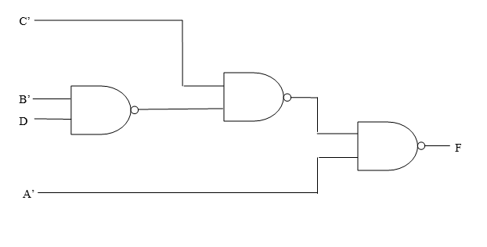

(b)

v

v

|  |  |  |  |  |
| --- | --- | --- | --- | --- |
| A, B →  C, D ↓ | 00 | 01 | 11 | 10 |
| 00 | 0 | 0 | 0 |  |
| 01 | 0 |  | v | 0 |
| 11 | 0  v  v |  |  | 0 |
| 10 | 0  v |  |  | 0 |

F’ = A’B’ + B’C’ + B’D + BC’D’

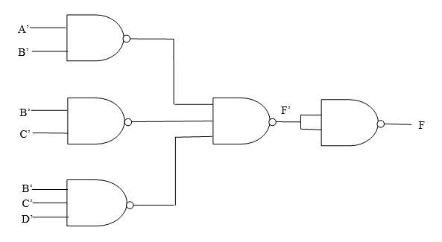

**Q. 18. Give three possible ways to express the function F with eight or fewer literals.**

**F (A, B, C, D) = Σ (0, 2, 5, 7, 10, 13)**

Ans.

|  |  |  |  |  |
| --- | --- | --- | --- | --- |
| A, B →  C, D ↓ | 00 | 01 | 11 | 10 |
| 00 | 1  v |  | v |  |
| 01 |  | 1  v | 1 |  |
| 11 |  | 1 |  |  |
| 10 | 1  v  v |  |  | 1  v |

First possible way, (1) F = A’B’D’ + A’BD + BC’D + B’CD’

Therefore, F = B’D’ (A + C’) + BD (A’ + C’)

|  |  |  |  |  |
| --- | --- | --- | --- | --- |
| A, B →  C, D ↓ | 00 | 01 | 11 | 10 |
| 00 |  | 0  v | 0 | 0  v |
| 01 | 0 |  |  | 0  v  v |
| 11 | 0  v |  | 0  v | 0  v |
| 10 |  | 0 | 0  v |  |

Second possible way, (2) F’ = B’D + BD’ + ABC + AB’C’

Therefore, F’ = [B’ + D (A’ + C’)] [B + D’ (A’ + C)]

Third possible way, (3) F’ = B’D + BD’ + AC’D’ + ACD

Therefore, F’ = [D’ + B (A’ + C)] [D + B’ (A’ + C)]

**Q. 19. Find eight different two-level gate circuits to implement**

**F = xy’z + x’yz + w**

Ans.

1. AND-OR

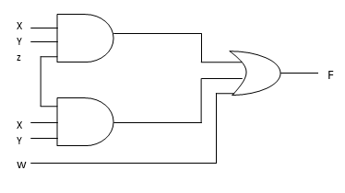

2. NAND-NAND :

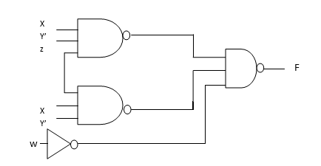

3. OR-AND :

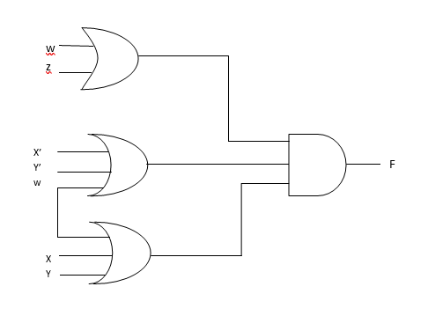

4. NOR-NOR :

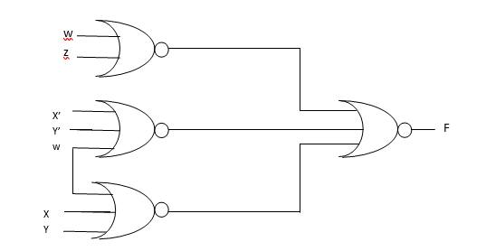

5. AND-NOR :

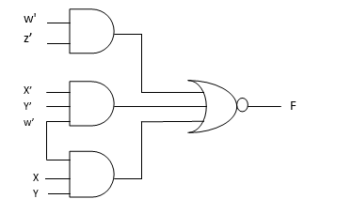

6. NAND-AND :

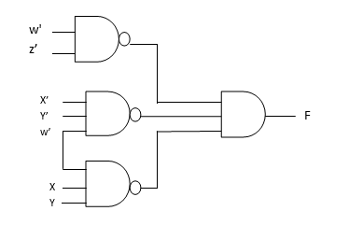

7. OR-NAND :

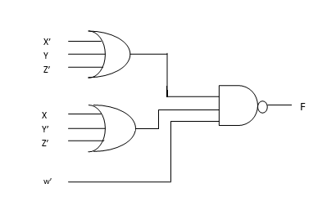

8. NOR-OR :

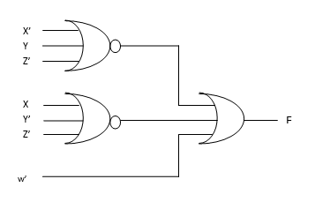

**Q. 20. Implement the function F with the following two-level forms: NAND-AND, AND-NOR, OR-NAND and NOR-OR. F(A, B, C, D) = Σ (0, 1, 2, 3, 4, 8, 9, 12)**

Ans.

|  |  |  |  |  |
| --- | --- | --- | --- | --- |
| A, B →  C, D ↓ | 00 | 01 | 11 | 10 |
| 00 | 1 | 1  v | 1 | 1  v |
| 01 | 1  v | 0 | 0 | 1 |
| 11 | 1  v | 0 | 0  v | 0 |
| 10 | 1 | 0 | 0  v | 0  v |

Two level NAND-AND

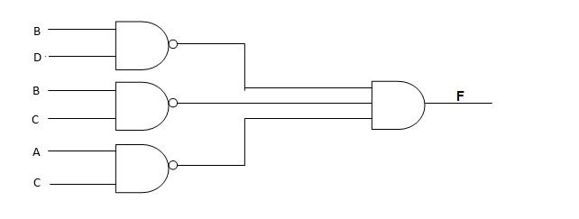

Two level AND-NOR

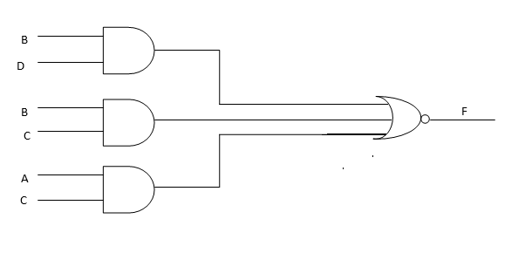

Two level OR-NAND

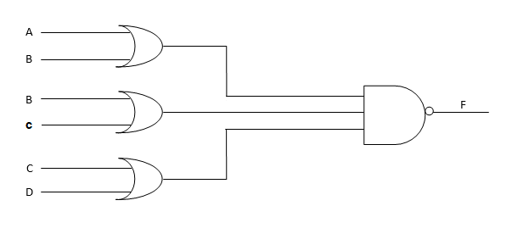

Two level NOR-OR

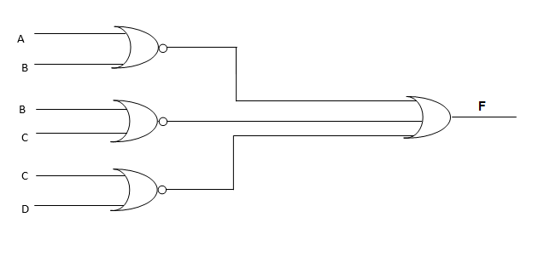

**Q. 21. List the eight degenerate two-level forms and show that they reduce to a single operation. Explain how the degenerate two-level forms can be used to extend the number of inputs to a gate.**

Ans.

The maximum number of levels that are present between inputs and output is two in two level logic. That means, irrespective of total number of logic gates, the maximum number of Logic gates that are present cascaded between any input and output is two in two level logic. Here, the outputs of first level Logic gates are connected as inputs of second level Logic gates.

Consider the four Logic gates AND, OR, NAND & NOR. Since, there are 4 Logic gates, we will get 16 possible ways of realizing two level logic. Those are AND-AND, AND-OR, ANDNAND, AND-NOR, OR-AND, OR-OR, OR-NAND, OR-NOR, NAND-AND, NAND-OR, NANDNAND, NAND-NOR, NOR-AND, NOR-OR, NOR-NAND, NOR-NOR.

These two-level logic realizations can be classified into the following two categories.

* Degenerative form
* Non-degenerative form

**Degenerative Form**

If the output of two-level logic realization can be obtained by single logic gate then it is called degenerative form.Obviously, the number of inputs of single Logic gate increases. Due to this, the fan-in of Logic gate increases. This is an advantage of degenerative form.

1. AND-AND Logic

In this logic realization, AND gates are present in both levels. Below figure shows an example for AND-AND logic realization.

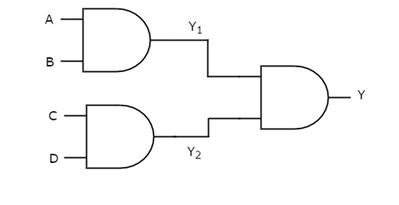

We will get the outputs of first level logic gates as Y1=AB and Y2=CD

These outputs, Y1 and Y2are applied as inputs of AND gate that is present in second level. So, the output of this AND gate is

Y=Y1Y2

Substitute Y1 and Y2values in the above equation.

Y=(AB)(CD)

⇒Y=ABCD

Therefore, the output of this AND-AND logic realization is ABCD. This Boolean function can be implemented by using a 4 input AND gate. Hence, it is degenerative form.

2. AND-NAND Logic

In this logic realization, AND gates are present in first level and NAND gates are present in second level. The following figure shows an example for AND-NAND logic realization.

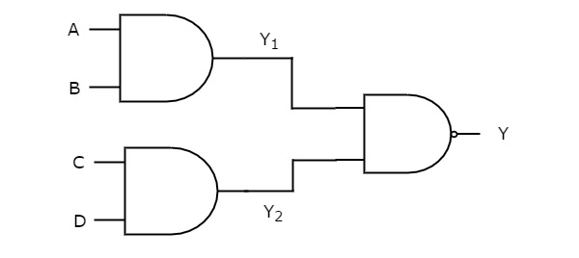

Previously, we got the outputs of first level logic gates as Y1=AB and Y2=CD

These outputs,Y1 and Y2 are applied as inputs of NAND gate that is present in second level. So, the output of this NAND gate is

Y=(Y1Y2)/

Substitute Y1 and Y2 values in the above equation.

Y=((AB)(CD))

⇒Y=(ABCD)/

Therefore, the output of this AND-NAND logic realization is (ABCD)/. This Boolean function can be implemented by using a 4 input NAND gate. Hence, it is degenerative form.

3. OR-OR Logic

In this logic realization, OR gates are present in both levels. The following figure shows an example for OR-OR logic realization.

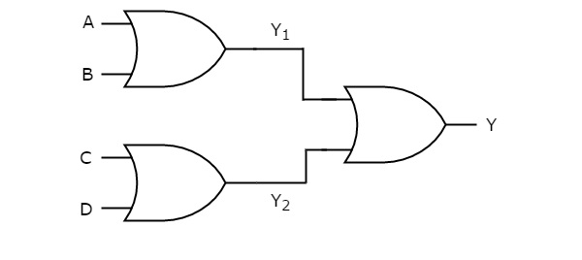

We will get the outputs of first level logic gates as Y1=A+B and Y2=C+D

These outputs, Y1 and Y2 are applied as inputs of OR gate that is present in second level. So, the output of this OR gate is

Y=Y1+Y2

Substitute Y1 and Y2 values in the above equation.

Y=(A+B)+(C+D)

⇒Y=A+B+C+D

Therefore, the output of this OR-OR logic realization is A+B+C+D. This Boolean function can be implemented by using a 4 input OR gate. Hence, it is degenerative form.

4. OR-NOR Logic

In this logic realization, OR gates are present in first level and NOR gates are present in second level.The following figure shows a example for OR-NOR logic realization.

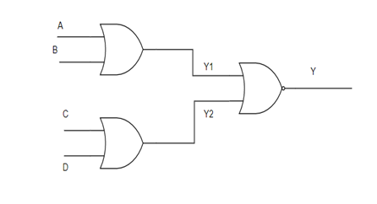

We will get the outputs of first level logic gates as Y1=A+B and Y2=C+D.

These outputs Y1 and Y¬2 are applied as inputs of NOR gate that is present in second level. So, the output of this NOR gate is

Y=(Y1+Y2)/

Substitute Y1 and Y2 values in the above equation.

Y=(A+B+C+D)/

Therefore, the output of this OR-NOR logic realization is (A+B+C+D)/. This Boolean function can be implemented by using a 4 input NOR gate. Hence, it is degenerative form.

5. NOR-NAND Logic

In this logic realization, NOR gates are present in first level and NAND gates are present in second level.The following figure shows a example for NOR-NAND logic realization.

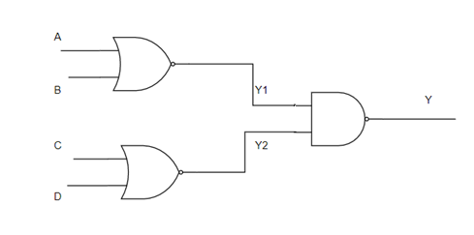

We will get the outputs of first level logic gates as Y1=(A+B)/ and Y2=(C+D)/

These outputs Y1 and Y2 are applied as inputs of NAND gate that is present in second level. So, the output of this NAND gate is

Y=(Y1Y2)/

Substitute Y1 and Y2 values in the above equation.

Y=((A+B)/(C+D)/)/

Y=((A+B)+(C+D)) [Using De Morgan’s Law]

Y=A+B+C+D

Therefore, the output of this NOR-NAND logic realization is (A+B+C+D). This Boolean function can be implemented by using a 4 input OR gate. Hence, it is degenerative form.

6. NAND-NOR Logic

In this logic realization, NAND gates are present in both levels. The following figure shows an example for NAND-NOR logic realization.

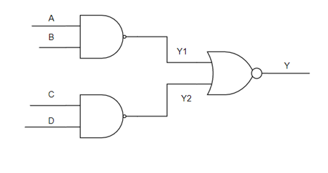

We will get the outputs of first level logic gates as Y1=(AB)/ and Y2=(CD)/

These outputs, Y1 and Y2 are applied as inputs of NOR gate that is present in second level. So, the output of this OR gate is

Y=(Y1+Y2)/

Substitute Y1 and Y2 values in the above equation

Y=((AB)/+(CD)/)/

Y=ABCD [using De Morgan’s Law]

Therefore, the output of this NAND-NOR logic realization is ABCD. This Boolean function can be implemented by using a 4 input AND gate. Hence, it is degenerative form.

7. NOR-AND

In this logic realization, NOR gates are present in both levels. The following figure shows an example for NOR-AND logic realization.

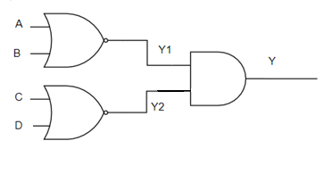

We will get the outputs of first level logic gates as Y1=(A+B)/ and Y2=(C+D)/

These outputs, Y1 and Y2 are applied as inputs of AND gate that is present in second level. So, the output of this AND gate is

Y=Y1.Y2

Y=(A+B)/.(C+D)/

Y=((A+B)+(C+D))/ [using De Morgan’s Law]

Y=(A+B+C+D)/

Therefore, the output of this NOR-NAND logic realization is (A+B+C+D)/.This Boolean function can be implemented by using a 4 input NORgate. Hence it is a degenerative form.

8. NAND-OR

In this logic realization, NAND gates are presentin first level and OR gates are present in second level. The following figure shows an example for NAND-OR logic realization.

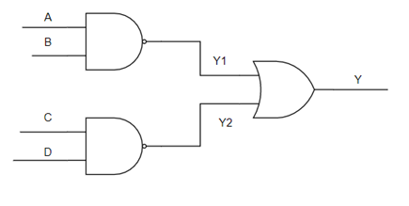

Previously, we got the outputs of first level logic gates as Y1=(AB)/ and Y2=(CD)/

These outputs, Y1 and Y2 are applied as inputs of OR gate that is present in second level. So, the output of this OR gate is

Y=(Y1+Y2)

Substitute Y1 and Y2 values in the above equation

Y=((AB)/+(CD)/)

Y=((AB)(CD))/ [using De Morgan’s Law]

Y=(ABCD)/

Therefore, the output of this NAND-OR logic realization is (ABCD)/.This Boolean function can be implemented by using a 4 input NAND gate. Hence it is a degenerative form.

**Q. 22. Simplify the following Boolean function F together with the don’t care conditions d; then express the simplified function in sum of minterms.**

**a.** F (x, y, z) = Σ (0, 1, 2, 4, 5); d (x, y, z) = Σ (3, 6, 7)

Ans.

|  |  |  |  |  |
| --- | --- | --- | --- | --- |
| x, y →  z ↓ | 00 | 01 | 11 | 10 |
| 0 | 1 | 1 | x | 1 |
| 1 | 1 | x  v | x | 1 |

Considering all the don’t care terms as 1, the simplified Boolean expression, F = 1

**b.** F (A, B, C, D) = Σ (0, 6, 8, 13, 14); d (A, B, C, D) = Σ (2, 4, 10)

Ans

v

v

|  |  |  |  |  |
| --- | --- | --- | --- | --- |
| A, B →  C, D ↓ | 00  v | 01 | 11 | 10 |
| 00 | 1 | x |  | 1 |
| 01 |  |  | 1  v |  |
| 11 |  |  | v |  |
| 10 | x  v | 1 | 1 | x |

The simplified Boolean expression, F = B’D’ + CD’ + ABC’D = Σ (0, 2, 6, 8, 10, 13, 14)

**c.** F (A, B, C, D) = Σ (1, 3, 5, 7, 9, 15); d (A, B, C, D) = Σ (4, 6, 12, 13)

Ans.

|  |  |  |  |  |
| --- | --- | --- | --- | --- |
| A, B →  C, D ↓ | 00 | 01 | 11 | 10 |
| 00 |  | x | x |  |
| 01 | 1 | 1 | x  v | 1 |
| 11 | 1 | 1  v | 1  v |  |
| 10 |  | x |  |  |

The simplified Boolean expression, F = CD’ + A’D + BD = Σ (1, 3, 5, 7, 9, 13, 15)

**Q. 23. Simplify the Boolean functions F together with the don’t care conditions d in (i) sum of products and (ii) product of sums.**

**a.** F (w, x, y, z) = Σ (0, 1, 2, 3, 7, 8, 10); d (w, x, y, z) = Σ (5, 6, 11, 15)

Ans.

v

v

v

|  |  |  |  |  |
| --- | --- | --- | --- | --- |
| w, x →  y, z ↓ | 00  v | 01 | 11  v | 10 |
| 00 | 1 | 0 | 0 | 1 |
| 01 | 1  v | x  v | 0  v | 0 |
| 11 | 1 | 1 | x | x |
| 10 | 1 | 0 | 0  v | 1 |

The simplified SOP form is, F = x’z’ + w’z

The compliment is, F’ = xz’ + wz

The simplified POS form is, F = (x’ + z) (w’ + z’)

**b.** F (A, B, C, D) = Σ (3, 4, 13, 15); d (A, B, C, D) = Σ (1, 2, 5, 6, 8, 10, 12, 14)

Ans.

v

v

v

|  |  |  |  |  |
| --- | --- | --- | --- | --- |
| A, B →  C, D ↓ | 00  v | 01 | 11 | 10 |
| 00 | 0 | 1 | x  v  v | x |
| 01 | x | x | 1 | 0 |
| 11 | 1  v | 0  v | 1 | 0  v |
| 10 | x | x | x | x |

The simplified SOP form is, F = BC’ + AB + A’B’D

The compliment is, F’ = B’D’ + AB’ + A’BD

The simplified POS form is, F = (B + D) (A’ + B) (A + B’ + D’)

**Q. 24. A logic circuit implements the following Boolean function, F = A’C + AC’D’. It is found that the circuit input combination A = C = 1 can never occur. Find a simpler expression for F using the proper don’t-care conditions.**

Ans.

|  |  |  |  |  |
| --- | --- | --- | --- | --- |
| A, C →  D ↓ | 00 | 01 | 11 | 10 |
| 0 | x  v | 1  v |  | 1  v |
| 1 | x | 1 |  |  |

Therefore, the simpler expression is, F (A, C, D) = C + AD’

**Q. 25. Implement the following Boolean function F together with the don’t-care conditions d using no more than two NOR gates. Assume that both the normal and complement inputs are available.**

**F (A, B, C, D) = Σ (0, 1, 2, 9 , 11) ; d (A, B, C, D) = Σ (8, 10, 14, 15)**

Ans.

|  |  |  |  |  |
| --- | --- | --- | --- | --- |
| A, B →  C, D ↓ | 00 | 01 | 11 | 10 |
| 00 |  | 0  v | 0 | x |
| 01 |  | 0 | 0 |  |
| 11 | 0 | 0  v | x |  |
| 10 |  | 0 | x | x |

So, F’ = B + A’CD

Therefor, F = (B + A’CD)’ = (B + (A + C’ + D’)’ )’

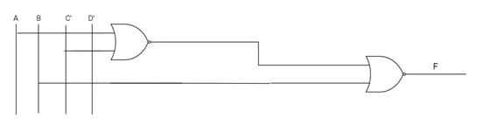

**Q. 26. Simplify the following Boolean function using the map presented in figure in Q. 30 (a). Repeat using the map of figure in Q. 30 (b)**

**F (A, B, C, D) = Σ (1, 2, 3, 5, 7, 9, 10, 11, 13, 15)**

Ans.

v

|  |  |  |  |  |
| --- | --- | --- | --- | --- |
| A, B →  C, D ↓ | 00 | 01 | 11 | 10 |
| 00 |  |  |  |  |
| 01 | 1 | 1 | 1  v | 1 |
| 11 | 1 | 1 | 1 | 1 |
| 10 | 1  v |  |  | 1 |

The simplified Boolean expression is. F = CB’ + D

A A’

D’

D’

D

B’

B

|  |  |  |  |
| --- | --- | --- | --- |
|  |  |  |  |
| 1 | 1  v  v | 1 | 1 |
| 1 | 1 | 1 | 1 |
| B | B | B | B |

C’ C C’

The simplified Boolean expression is, F = CB’ + D

Thus, both the expressions are same in both types of K-map.